Implicit and Explicit Cursor

An implicit cursor is a cursor that is automatically created by Oracle whenever a DML (INSERT, UPDATE, DELETE) or SELECT INTO statement is executed. Unlike explicit cursors, which are defined and controlled by the developer, implicit cursors are managed by Oracle internally.
Example:- Select * from Employees.
Simple SQL query but Oracle Open implicit cursor for the same automatically.
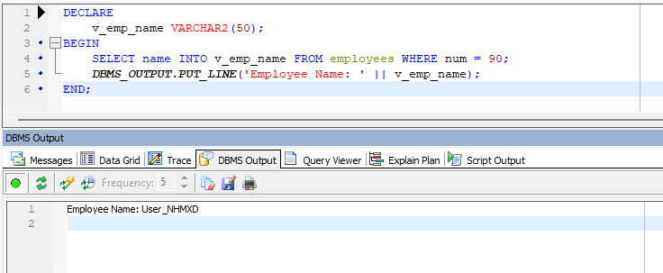

Implicit Cursor Attributes:
You can check the status of an implicit cursor using its attributes:
- SQL%FOUND – Returns TRUE if the last SQL statement affected one or more rows.
- SQL%NOTFOUND – Returns TRUE if the last SQL statement affected zero rows.
- SQL%ROWCOUNT – Returns the number of rows affected by the last SQL statement.
- SQL%ISOPEN – Always returns FALSE for implicit cursors because they are automatically closed after execution.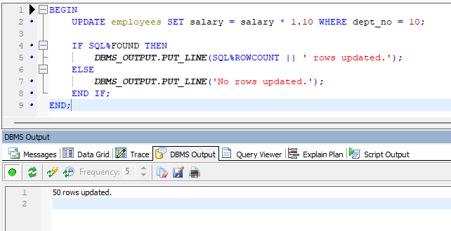

Explicit Cursor in Oracle
An explicit cursor is a user-defined cursor that is manually declared, opened, fetched, and closed. Unlike implicit cursors, explicit cursors provide more control over the result set and allow processing multiple rows one by one.
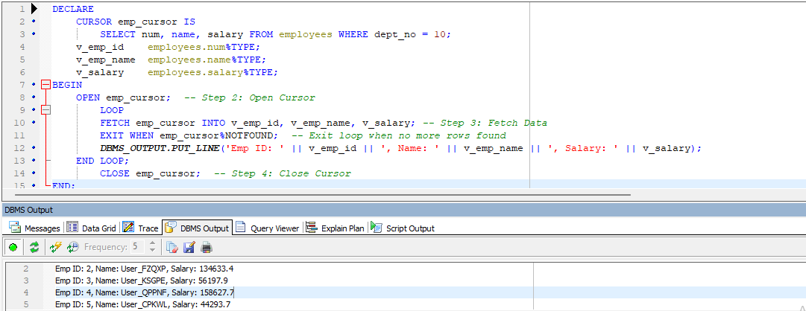

Explicit Cursor Attributes
Like implicit cursors, explicit cursors have attributes that help check their status:
- %FOUND – Returns TRUE if a row was fetched successfully.
- %NOTFOUND – Returns TRUE if no more rows are available.
- %ROWCOUNT – Returns the number of rows fetched so far.
- %ISOPEN – Returns TRUE if the cursor is open.

Why Use Explicit Cursors?
- Needed when fetching multiple rows (Implicit cursors work only for single-row queries).
- Allows better performance control.
- Useful when processing large data sets row by row.

